INTRODUCTION TO NETWORK PROTOCOLS

Q1. Use Wireshark to capture network traffic while you load www.spotify.com in your browser, then identify and note down at least two DNS packets and two HTTP or HTTPS packets in the capture.
Ans.
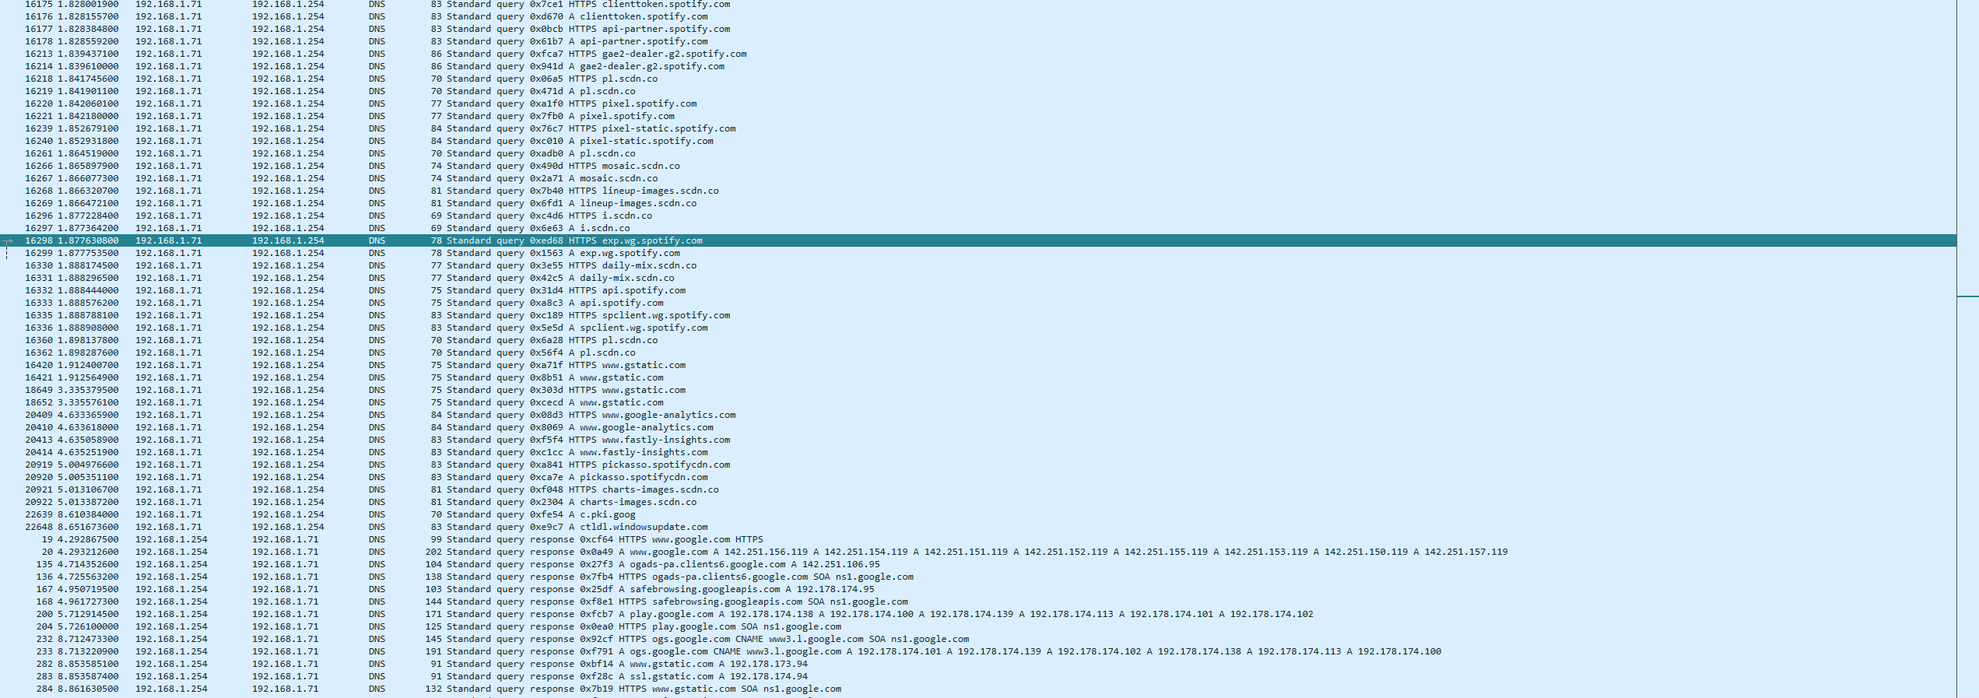
This was the network traffic while I was browsing spotify.com on a browser and here’s the following information about the Capture
Packet No. | Protocol | Source | Destination | Information
16175 | DNS | 192.168.1.71 | 192.168.1.254 | Standard query for HTTPS clienttoken.spotify.com
16176 | DNS | 192.168.1.71 | 192.168.1.254 | Standard query for A clienttoken.spotify.com

Q2. Simulate a DNS lookup for www.flipkart.com using the nslookup command in your terminal and write down the IP address returned along with a brief explanation of what this result means.
Ans.
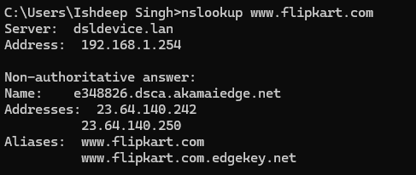
Returned IP Address – 23.64.140.242
Explanation: - The nslookup command asks a DNS server to find the IP address associated with the domain name www.flipkart.com. The returned IP address is the network address that your computer can use to locate Flipkart's server.
Q3. Explain the difference between HTTP and HTTPS by listing 3 key differences, and give a real-world example of an app or website you use that relies on HTTPS for secure communication.
Ans. HTTP vs HTTPS
Feature | HTTP | HTTPS
1. Security | Data is sent without encryption. | Data is encrypted using TLS.
2. Data protection | Information can potentially be read or modified during transmission. | Protects data from being easily read or modified in transit.
3. URL/Port | Usually uses http:// and port 80. | Usually uses https:// and port 443.

Real-world example
- Flipkart uses HTTPS to securely communicate between your browser/app and its servers. This helps protect information such as login credentials, personal details, and payment-related data while it is being transmitted.

Q4. Open Wireshark and filter for DNS protocol traffic. Try searching for a new website (one you haven't visited recently) in your browser and describe the sequence of DNS queries and responses you observe. Hint: Look for packets with 'Standard query' and 'Standard query response' in the Info column.
Ans. DNS Traffic Observation
Website: www.flipkart.com
Wireshark filter: dns
Packet | Type | Observation
419 | Standard query | Computer 192.168.1.71 asks DNS server 192.168.1.254 for rukminim2.flipkart.com.
424 | Standard query response | DNS server responds with a CNAME and IP addresses for the Flipkart domain.
615 | Standard query | Computer requests the IP address of a1.rome.api.flipkart.com.
618 | Standard query response | DNS server returns an IP address (103.243.33.5).
620 | Standard query | Computer requests HTTPS information for a2.rome.api.flipkart.com.
627 | Standard query response | DNS server returns CNAME information and several IP addresses.

Sequence: - Computer → DNS Server: Standard query → DNS Server → Computer: Standard query response → Computer → DNS Server: another query → DNS Server → Computer: response.
Q5. Pick any one protocol from DNS, DHCP, FTP, or SNMP (other than HTTP/HTTPS) and write a short scenario describing how it would be used in a real-world app or service you use (for example, how DHCP helps your phone connect to Wi-Fi when you open Instagram at a cafe).
Ans. Protocol: DHCP
Scenario: - When I connect my phone to Wi-Fi at a cafe and open Instagram, DHCP (Dynamic Host Configuration Protocol) helps my phone obtain the network settings it needs. The cafe's Wi-Fi router assigns my phone an IP address, along with information such as the default gateway and DNS server. Once these settings are received, my phone can communicate over the internet and load Instagram.

